Welcome to Ms. Rogstad’s 6th Grade!

**Friday Folders:** Each Friday students bring home a Friday Folder. This folder contains information from the school and the classroom and graded student work. Please look through Friday Folders each weekend and return the folder the following Monday.

**Class Newsletter:** A newsletter for our class will be updated most weeks. The newsletter, along with homework and calendar updates, is available on the class website. http://rogstads6thgrade.weebly.com/

**Homework and Planners:** Homework is meant to provide students with skill practice or to prepare for in class learning. **Math** homework will be fairly consistent Monday through Thursday. **Literacy** homework is typically assigned as work started in class needs to be finished or to prepare reading or responses for the following day in class. Some discussions also take place on our class blog. Therefore, **DUE DATEs will vary** but it is important that students stay caught up so that they can participate in class work.

Please know that since homework is completed at home, and I know that you have busy lives and schedules outside of school, you are free to make adjustments as needed and I can work with students to get caught up through extensions and modifications. Just communicate those needs to me.

**Planners** were given to students during the second week of school. We have time to fill out planners daily. Assignments can be found on the class website as well. There will be time at the end of each day to fill out planners**C:\Documents and Settings\Jeffco\Local Settings\Temporary Internet Files\Content.IE5\8X9NZYPL\MC900229657[1].wmf**.

**Field Trips and Guest Speakers:** As these events are planned, permission slips will go home in Friday folders. Field trips are not included in fees and money will be collected with permission slips. We’re always happy to have parents join as chaperones!

**Snacks and Birthday Treats:** Students may bring snacks daily. I ask that students bring **healthy snacks** only- no chips, cookies, candy, etc. Students may also bring a **water bottle** (water only**)**. Students are not to share snacks.

Your child may bring treats for birthdays. Please try to give me a heads up for planning purposes. Allergies in the class include nuts and peanuts so please plan accordingly. If your child has allergies and would like to bring a baggie with a few “safe” treats for birthday celebrations, I am happy to store them and pull them out when occasions arise.

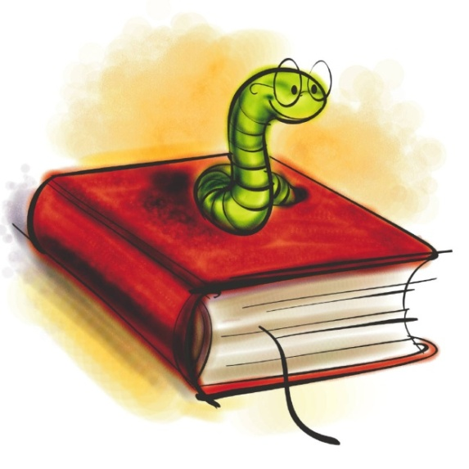**Daily Schedule:**

* 8:05-8:25– Arrival and Warm-Up
* 8:25-9:25 Math
* 9:25-10:00 Science/Social Studies
* 10:00-10:45 Specials
* 10:45-11:20 Science/Social Studies
* 11:20-12:50 Literacy
* 12:50-1:35 Recess/Lunch
* 1:35-2:35 Writing
* 2:35-2:50 Planners, Homework and Clean Up
* Dismissal at 2:50

**Literacy (Reading, Writing, and Word Study):**  Instruction is tailored to the needs of each student and is based on ongoing assessment. Components of literacy instruction include:

* Shared reading and writing (whole group)
* Guided reading and writing (small group)
* Independent reading and writing (one on one)
* School Wide Enrichment Model-Reading (SEM-R)
* Writer’s Workshop
* Genre study
* Vocabulary
* Computer literacy

**Math:** Coronado is using Big Ideas for 6th GT math. Students can access their books from home at the Big Ideas website. They will receive log in info when we return from Outdoor Lab. Students are assessed throughout math units and receive instruction specific to their needs (reviewing, re-teaching, extending). In addition to Big Ideas, I use supplemental resources including M3, problems of the week, computer based resources and more. The sequence of units is:

* Reasoning with Integers and Rational Numbers
* Modeling with Expressions, Equations, and Inequalities
* Modeling Proportional Relationships
* 2D and 3D Geometry
* Probability and Statistics
* Problem Solving with Rational Numbers

**Science:** 6th grade science units include states and properties of matter, relationships with mass, weight and volume, Earth's processes and surfaces, relationships of biosphere and hydrosphere, organisms and their environments.

**Social Studies:** 6th grade social studies units includes Western Hemisphere: History and Culture, Economics and Politics and Geography

**Technology Challenge:** This year’s project will have a community outreach and service. We will be partnering with a second grade class in Montbello to serve as mentors and help build study tools to increase access to and strengthen literacy.

For details about our learning focus each week, please check in regularly with the class website!

**Contact Information:** The best way to get in contact with me is through email. My email address is [Lrogstad@jeffco.k12.co.us](mailto:Lrogstad@jeffco.k12.co.us)

The class website is <http://rogstads6thgrade.weebly.com/>