Welcome to Ms. Rogstad’s 6th Grade!
Friday Folders: Each Friday students bring home a Friday Folder. This folder contains information from the school and the classroom and graded student work. Please look through Friday Folders each weekend and return the folder the following Monday.
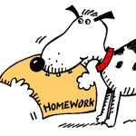
Website: The website features the class newsletter, homework assignments, important dates, and links students may find useful for various projects. The newsletter will be updated at least every other week. http://rogstads6thgrade.weebly.com/
Homework and Planners: Homework is meant to provide students with additional skill practice and preparation for in class learning. In recognition of extracurricular activities, and the importance of family time, Coronado teachers are working to make sure homework is meaningful and honors the time of students and their families. As parents, feel free to make adjustments as needed. Those changes can be communicated to me via a quick note on your child’s assignment.
- Math- Students will have math homework most week days, Monday-Thursday. Math assignments should take 15-20 minutes. If your child is spending considerably longer, it’s OK to let him or her stop for the day as we will take time in class to go over solutions and questions for most assignments.
- Literacy homework is typically reading or writing assignments that need to be completed to participate in class work and discussions. Annotation or a short comprehension assignment will often accompany the reading. Sometimes students have an opportunity to begin the assignment in class so the amount of reading time may vary from student to student. On nights without assigned reading, students should read a text of their choice for at least 20 minutes. Any genre and text format (physical book, e-reader, audio book) is acceptable for this assignment. Literacy homework is assigned Monday-Thursday
- Unfinished Work- Students who fall behind on class work may be asked to take work home to catch up. This is the only homework that would be assigned on a weekend. Otherwise I try to keep weekends homework free.
- Additional Homework- We will have projects in science and social studies Most of the work will be completed in class. Students who don’t complete work in class may need to catch up at home. Additionally, there will be several visual pieces that need to be completed at home. Specific directions and due dates will be provided and posted on the website with ample time to complete the assignment.
Planners Each student received a planner and they are given time to fill them out daily as I write assignments on the website. Through September, I will initial planners at the end of the day while we form the habit of using them. After that, students will be expected to independently monitor homework through planners or by accessing the class website. This is to help students build independence for middle school.
Field Trips and Guest Speakers: As these events are planned, permission slips will go home in Friday folders. Field trips are not included in fees and money will be collected with permission slips. We’re always happy to have parents join as chaperones!
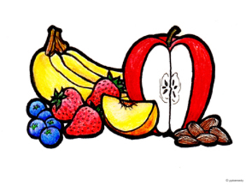
Snacks and Birthday Treats: There is time for a snack each morning. I ask that students bring healthy snacks - no chips, cookies, candy, etc. To avoid unintended catastrophes with germs and food allergies, students are asked not to share snacks. Students may keep a water bottle (water only) with them throughout the day and refill it as needed.
Some families choose to send treats for a student’s birthday, though it is certainly not required. A heads up is always appreciated so that I can make room in the day to celebrate. Allergies in the class include nuts, peanuts, watermelon and kiwi; please plan accordingly. If your child has allergies and you would like to send a baggie with safe treats for celebrations, I am happy to store and distribute them as needed.

Daily Schedule:

- 8:05-8:25– Arrival and Warm-Up
- 8:25-9:25 Math
- 9:25-10:00 Science/Social Studies
- 10:00-10:45 Specials
- 10:45-11:20 Science/Social Studies
- 11:20-12:50 Literacy
- 12:50-1:35 Recess/Lunch
- 1:35-2:40 Writing
- 2:40-2:50 Planners, Homework and Clean Up
- Dismissal at 2:50

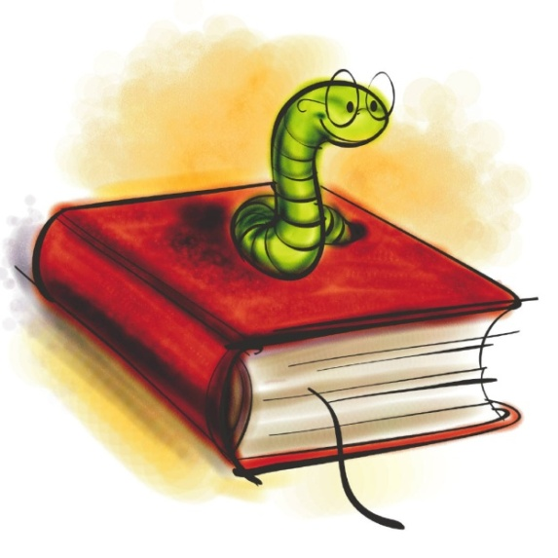
Literacy- Our center program accelerates literacy instruction by one year so we work with 7th grade standards. In literacy we work on reading, writing and speaking. Our goal is to understand how readers and writers engage with text to communicate the human experience. Instruction is tailored to the needs of each student and is based on ongoing assessment. Students are taught through whole group, small group and individual instruction. We use a variety of long and short texts throughout the year and writing is taught through genre study. Our units of study are:
- Interacting with Texts (reading)
- Narrative (writing)
- Examining Text Structures (reading)
- Feature Article (writing)
- Historical Influences: Fiction and Nonfiction
- Literary Analysis (writing)
- Critical Viewing: Comparing Text and Media (reading)
- Consumer Product Review (writing)
6th grade readers are entering the world of young adult literature which comes with increasingly mature language and subject matter. This is especially true for gifted learners who are often reading at the 7th grade level or above. Please know that as parents, you have the ultimate veto power in what your child reads. Make sure to have conversations with your child about selecting texts that honor your family’s values. If you ever have a concern about a text your child is reading, whether self-selected or assigned, feel free to let me know and I can help direct your child to a text that is a better fit.

Math: Our center program accelerates math instruction by one year so we work on 7th grade standards. Coronado uses Big Ideas for 6th GT math. Students are assessed throughout math units and receive instruction specific to their needs (reviewing, re-teaching, extending). I always begin a unit with a pre-assessment. Students who show a high level of proficiency on the pre-test may be offered extension opportunities. However, it is important that students have a solid conceptual understanding of content before moving forward.
In addition to Big Ideas, we will be working regularly with some real world problem solving opportunities in order to demonstrate mathematical communication and processes. I will provide students with Kahn Academy accounts which can be accessed from any computer or tablet. Kahn provides students individually tailored math instruction and practice and can be used for additional practice or extensions at school and home.
Our math units are:
- Reasoning with Integer and Rational Number Operations
- Modeling with Expressions, Equations and Inequalities
- Modeling Proportional Relationships
- 2D and 3D Geometry
- Probability and Statistics
- Problem Solving with Rational Numbers
Science and Social Studies- Our curriculum for these areas is not accelerated so we work with 6th grade standards and extend content as needed. Both subjects will include some project based learning. Our units of study include:
Science:
- Matter, its States and Properties
- Mass, Weight, Volume and Density
- Earth’s Processes and Surfaces of the Earth
- Water and the Living Environment
- Organisms and their Environment
May 15th-19th is Outdoor Lab for Coronado 6th Graders. Many students describe this as the highlight of 6th grade and we are lucky to make this our culminating activity of the elementary school experience! Students will spend a week at the Mt. Evans Camp, extending their science learning as we explore our beautiful Colorado Mountains. Specific information will be provided at a parent information night later this year.
Social Studies: 6th grade social studies focuses on the culture, geography and economics of the Western Hemisphere. Units include:
- Early Cultures and Development Over Time
- Economics and Political Interaction
- Exploring Geographic Issues
Technology Challenge: This is a GT department project meant to provide students with the opportunity to work with technology and build 21st century skills of collaboration and creative thinking. At the department level, tech challenge is being revised a bit.
Last year my 6th graders had the opportunity to create a meaningful service learning project. A specific plan is not yet in place for this year while I wait to hear about changes to the project requirements. However, students will have the opportunity to work regularly with technology in class throughout the year. In the past I’ve taught students to present learning through
- Google Docs, Forms, Sheets and EasyBib
- Stop Motion Animation
- iMovie
- Publisher(Publishing Articles)
- Kahoot (Creating an Interactive Quiz
- Weebly (Creating Websites)
- Crowd Sourcing
I’m always looking for ways to bring technology into the classroom to engage learners and provide students with meaningful and creative ways to demonstrate learning. Who knows what we’ll create this year but when we do, we’ll be sure to share it with you!
Contact Information: The best way to get in contact with me is through email.
My email address is: lrogstad@jeffco.k12.co.us
Class Website: http://rogstads6thgrade.weebly.com

