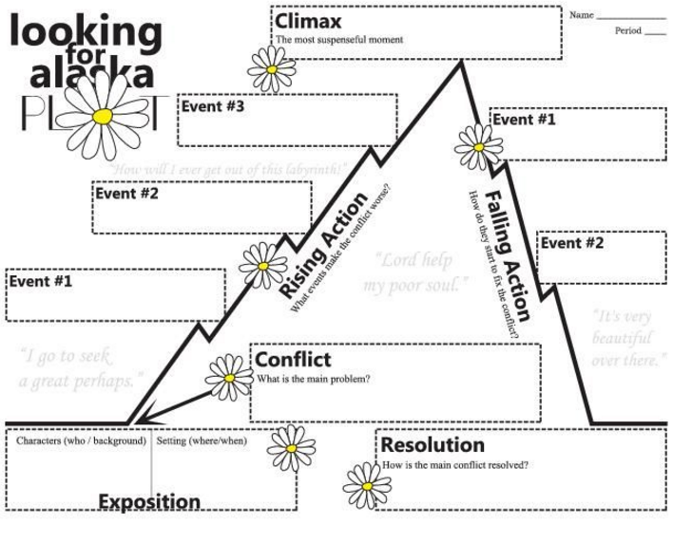

The narrator feels uncomfortable in the huge house that is different from her own and with Ashley, who she hardly knows.

Ashley learns that her mother has been replacing dead budgies since she was 3. It’s not Sweetpea

The narrator is more accepting of Ashley having learned about her life and the girls may seem to be beginning a friendship.

**Resolution**

The narrator and Ashley hold a funeral for the budgie

The narrator feels uncomfortable and wants to go home.

Climax: The girls enter Ashley’s room only to discover the budgie is DEAD!!!

Ashley talks about her feelings about getting older and about her budgie.

Ashley gives the narrator a tour of the house and talks nonstop about her dreams.

The story takes place at Ashley’s enormous house. The main characters are Ashley and the narrator.

“Thirteen and a Half”

By Rachel Vail

Plot